Fiche Bristol Operations
Week 1:
Excess supply = Wasted resources
Excess demand = Lost revenue
A process is a procedure that has an input (raw materials or customers) that goes through a transformation process involving the use of resources in order to be outputted (goods, served customers)
Flow time: is the time a unit takes from entering to leaving the process.
Cycle Time: is the time bet ween consecutive units leaving the process
Capacity: is the maximum output rate when working at full speed
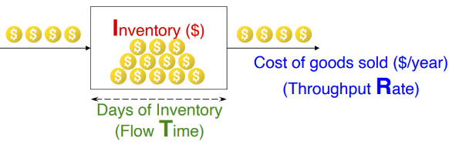
A bottleneck refers to a block or congestion that hampers the smooth operation of a system or a process.
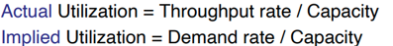
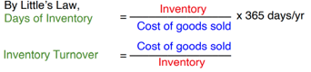

KPI :
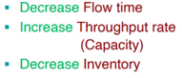
Inventory Week 2:
- If demand < capacity => there is no inventory, the throughput rate = demand
- If demand > capacity => inventory build-up rate = Demand – Capacity, Throughput rate = Capacity rate
- Demand<Capacity => Inventory deplete rate = Capacity – Demand, Throughput rate = Capacity rate
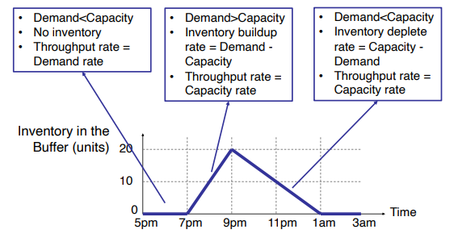
To find the total waiting time of the process, we must calculate the area under the curve.

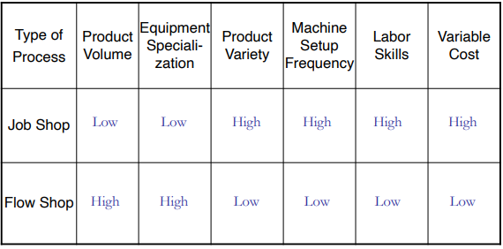
Flow Shop = more flexibility
Job shop = more flexibility

Note :
- Job shop are better for discrete projects that you only do ounce (like the dissertation)
- Flow shop are more appropriate when you have an assembly line (ol production for instance)
Week 3:
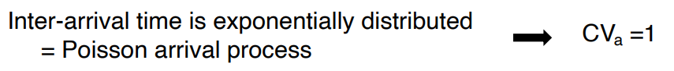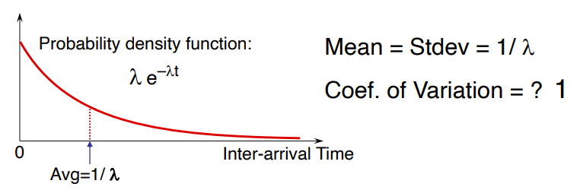
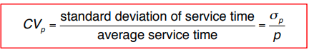
Poisson process CVa = CVb = 1
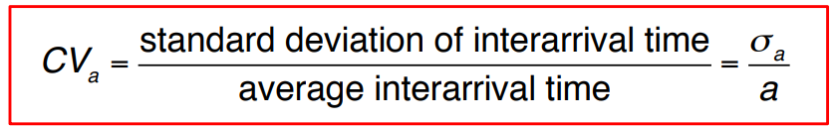
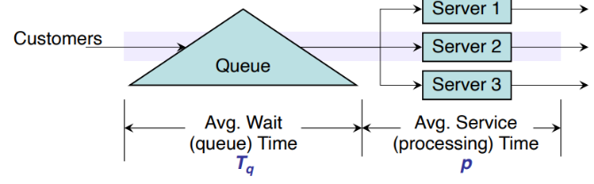
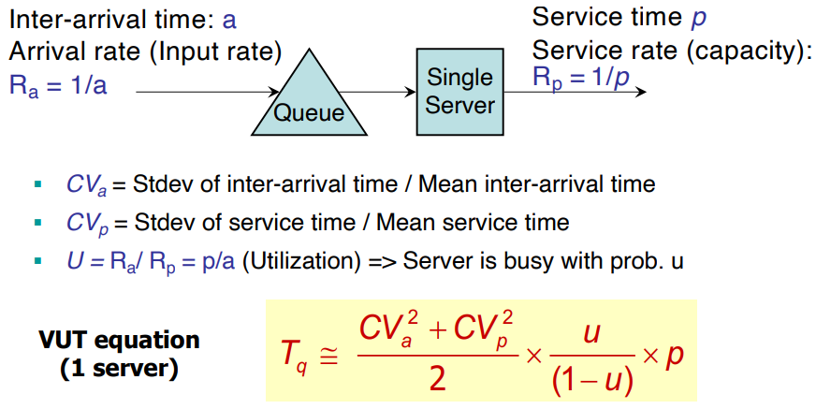
P = Average processing time
A = demand
Average people waiting = average waiting time (Vut)/ inter arrival time(a)
P(customer is served immediately) = 1-u

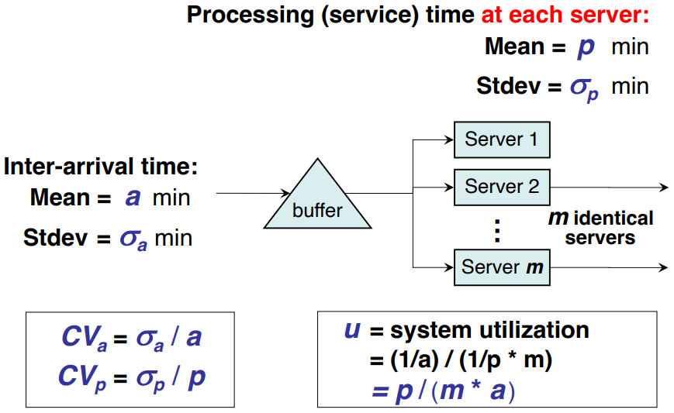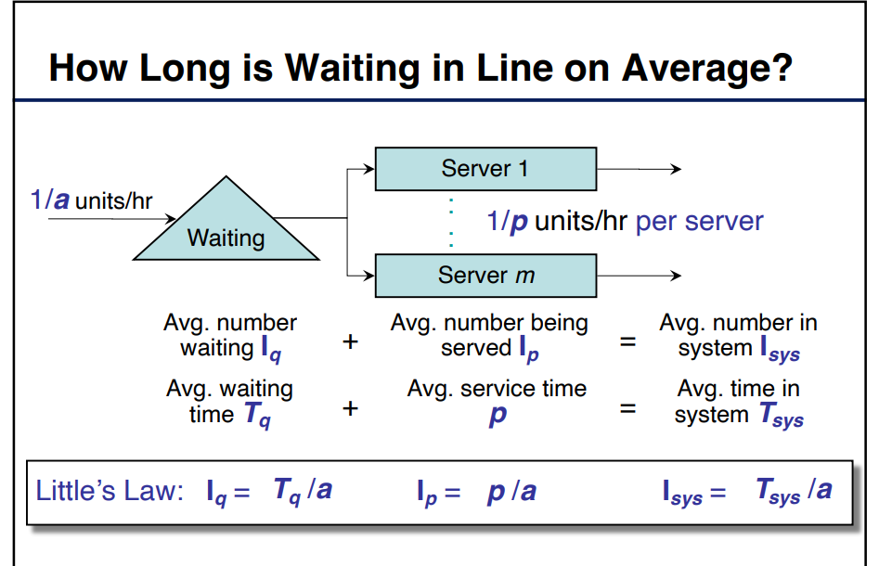
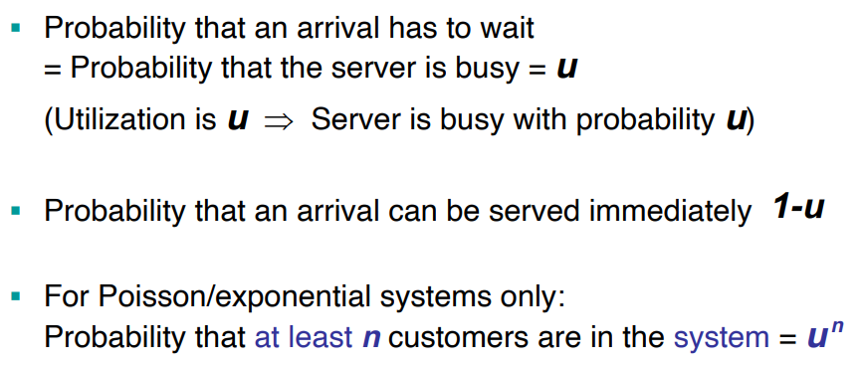
Target stock level
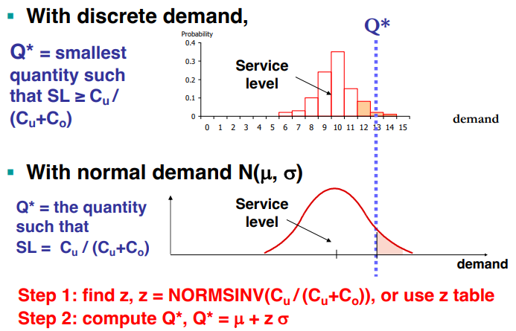

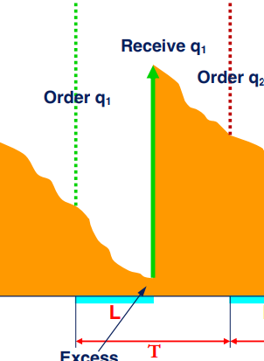
Week 4
L = from the order to the reception
T = from one order to the other
